**The Present Status of Work in the Black Rural South**

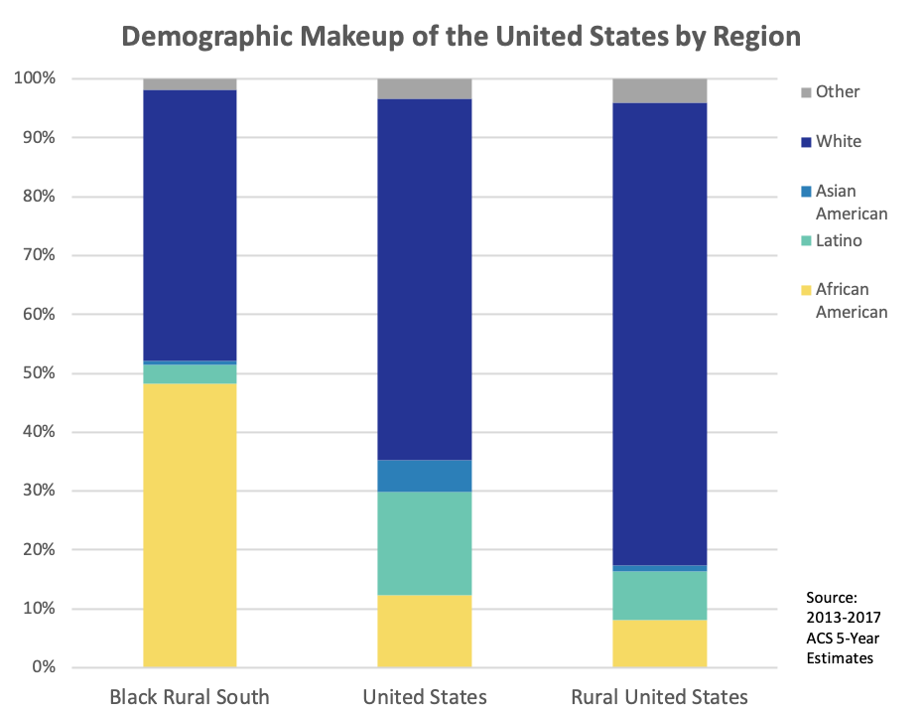

Figure 1: Demographic breakdown of counties in the Black Rural South, counties in the Rural United States, and counties in the United States into ‘Not Hispanic – Black or African American only’, ‘Hispanic/Latino’, ‘Not Hispanic – Asian only’, ‘Not Hispanic – White only’, and ‘Not Hispanic – Other Race or Two or More Races’.

* African Americans make up 48.3% of the population in the Black Rural South. This is four times higher than in the United States overall, and **six times higher** than in all rural counties.
* Not only is the Black Rural South very Black, it is also very Black and White. African Americans and Whites make up 94% of the Black Rural South. By comparison, Blacks and Whites together make up only 74% of the United States.

**Employment**

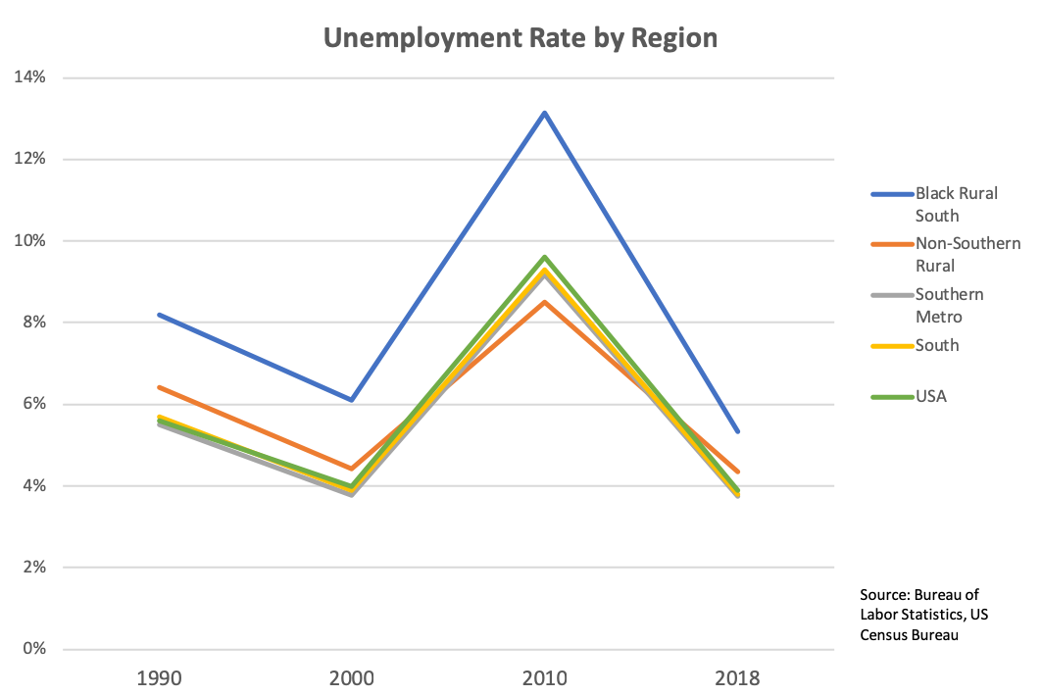

Figure 2: Average Non-Seasonally Adjusted Unemployment Rate in 1990, 2000, 2010, and 2018, weighted by 1990, 2000, 2010 Census Bureau Population and 2013-2017 ACS Population estimates respectively, of counties in the Black Rural South, Rural counties not in the South, Metro counties in the South, Southern counties, and the entire USA. This figure is **not** broken down by race.

**TODO: REWEIGHT BY LABOR FORCE INSTEAD OF POPULATION**

* This graph, shows the stark contrast, which has persisted over time, between the Black Rural South and the rest of the country. While all other regions cluster at or near a 6% unemployment rate, the Black Rural South consistently experiences an unemployment rate 2 percentage points higher than the rest of the country.
* The unemployment rate in the Black Rural South is also significantly more volatile than in other regions. From 2000 to 2010, the effects of the recession caused the unemployment rate in the Black Rural South to jump over 7 percentage points. By contrast, in non-southern rural counties, the unemployment rate only increased by 4 percentage points.

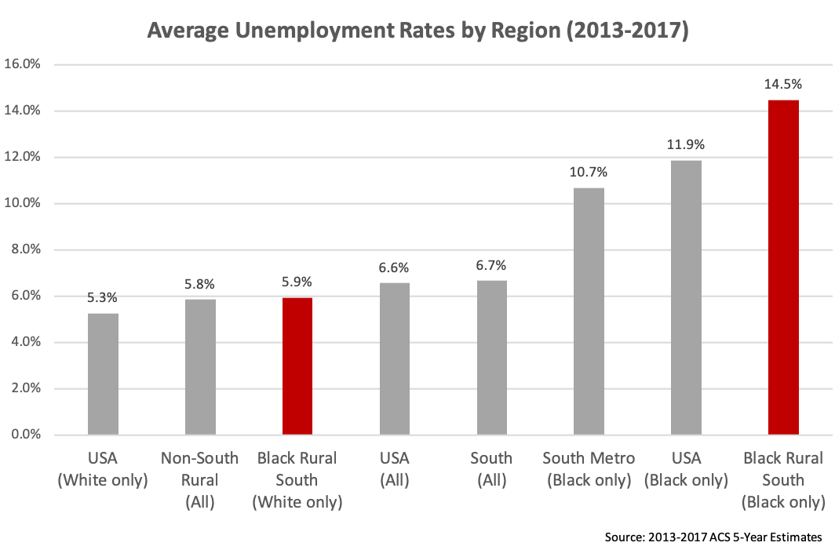

Figure 3: Average Unemployment Rate over 2013-2017, weighted by average labor force over 2013-2017, of counties in the Black Rural South, Rural counties not in the South, Metro counties in the South, Southern counties, and the entire USA, for the whole population and for demographic categories ‘Black or African American Alone’ and ‘White Alone, Not Hispanic or Latino’. Note that the White unemployment rate in the Southern Metro, not included in this figure, is 5.1%, just slightly below the White unemployment rate across the USA.

* The unemployment rate among African Americans in the Black Rural South is 14.5%. This is 2.2 times the national average, and 2.5 times the average among rural counties outside of the South.
* Not only is the Black unemployment rate in the Black Rural South higher than the general unemployment rate in other regions, it is also higher than the **Black** unemployment rate in other regions. Black unemployment in the Black Rural South is 2.6 percentage points higher than Black unemployment in the USA, and 3.8 percentage points higher than Black unemployment in Southern Metro counties.
* The White unemployment rate in the Black Rural South, however, is **lower** than the national average, and comparable to the unemployment rate across other rural counties outside of the South. Black unemployment in the Black Rural South is **8.5 percentage points higher** than White unemployment in the Black Rural South. (Should this be in the White unemployment section?)
* The Labor Force Participation Rate in the Black Rural South, which averages to 51.8%, is 8.1 percentage points lower than in other Rural counties outside the South, and 11.6 percentage points lower than the rest of the USA.

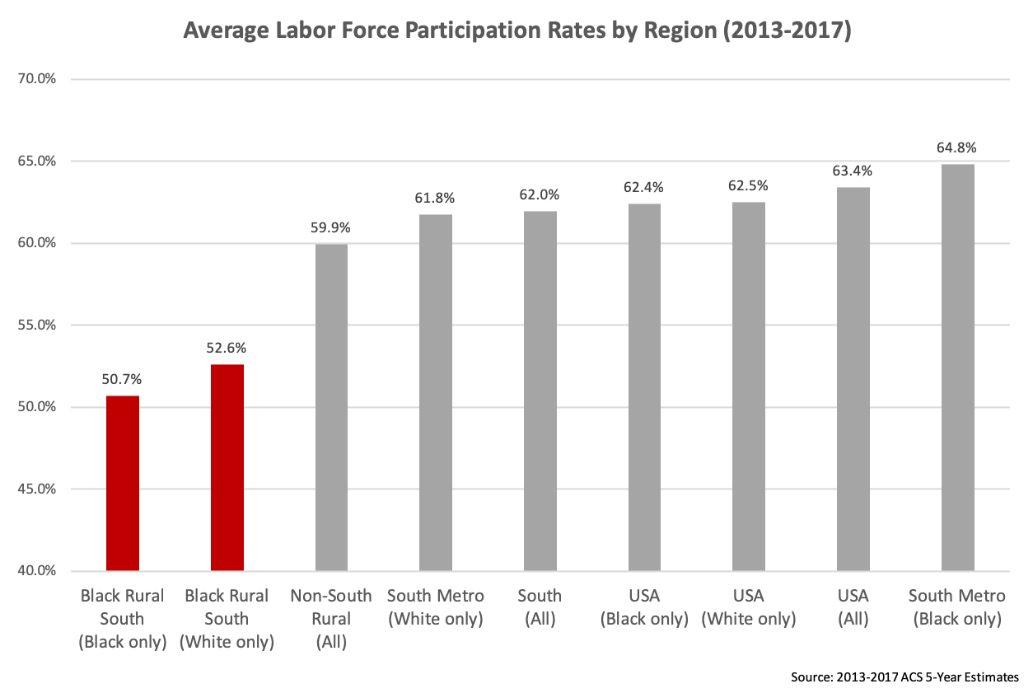

Figure 4: Average Labor Force Participation Rate over 2013-2017 of counties in the Black Rural South, Rural counties not in the South, Metro counties in the South, Southern counties, and the entire USA, for the whole population and for demographic categories ‘Black or African American Alone’ and ‘White Alone, Not Hispanic or Latino’.

* While African Americans have a higher Labor Force Participation Rate than Whites in Southern Metro counties, and a similar rate across the entire USA, African Americans in the Black Rural South have a **lower** Labor Force Participation Rate than Whites, by nearly 2 percentage points.

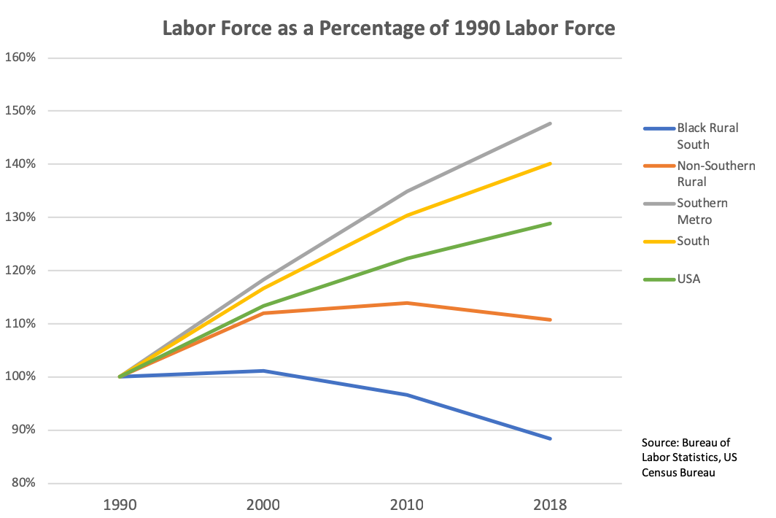**TODO: CHANGE TO EPOP(?)!!!**

Figure 5: Non-Seasonally Adjusted Annual Average Labor Force Level in 1990, 2000, 2010, and 2018 of counties in the Black Rural South, Rural counties not in the South, Metro counties in the South, Southern counties, and the entire USA. This figure is **not** broken down by race.

* The Black Rural South is the only area where the labor force is shrinking. In 2018, while the population grew by 8%, the size of the labor force in the Black Rural South **shrank** by 12%.
* 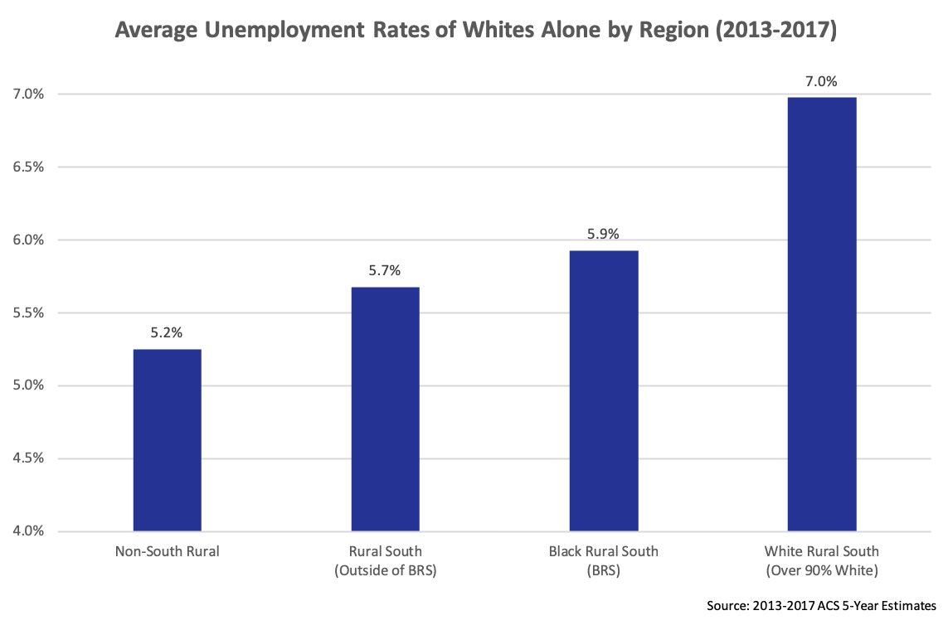

Figure 6: Average Unemployment Rate over 2013-2017, weighted by average labor force over 2013-2017, for ‘White Alone, Not Hispanic or Latino’, of counties in the Black Rural South, Rural counties not in the South, Rural counties in the South that are not part of the ‘Black Rural South’, and White Rural South (Rural Counties in the South that are over 90% White).

**Income**

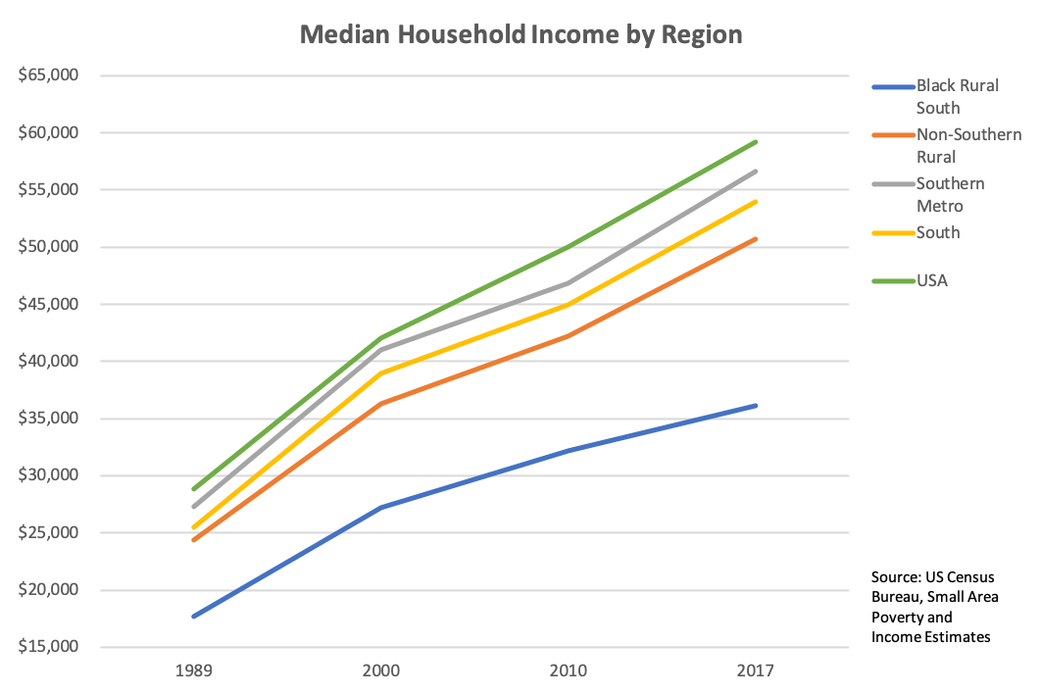

Figure 7: Median Household Income in 1989, 2000, 2010, and 2017, weighted by 1990, 2000, 2010 Census Bureau Population and 2013-2017 ACS Population estimates respectively, of counties in the Black Rural South, Rural counties not in the South, Metro counties in the South, Southern counties, and the entire USA. This figure is **not** broken down by race, and has **not** been adjusted for inflation.

* BRS is lowest – others are clustered
* Growth rate is also slowing

**TODO: REDO WEIGHTING WITH POPULATION BY RACE**

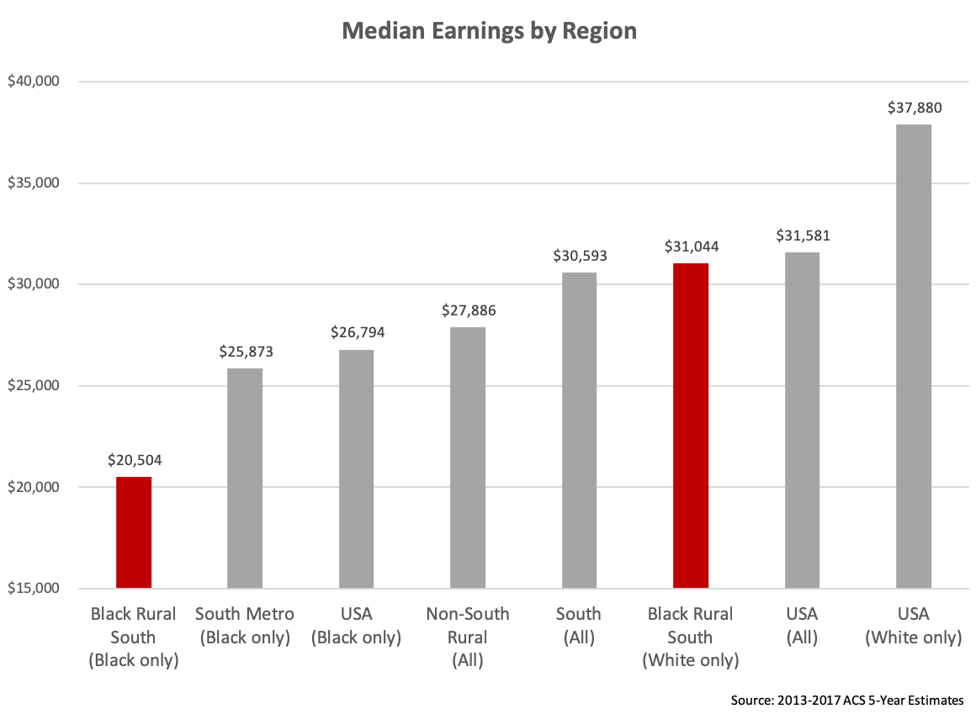

Figure 8: Median Earnings in the Past 12 Months among Population 16 Years and Older with Earnings in the Past 12 Months, Averaged over 2013-2017. Weighted by 2013-2017 ACS 5-Year Population Estimates. Data is for counties in the Black Rural South, Rural counties not in the South, Metro counties in the South, Southern counties, and the entire USA, for the whole population and for demographic categories ‘Black or African American Alone’ and ‘White Alone, Not Hispanic or Latino’. Note that the Median Earnings for Whites in the South Metro, not included in this graph, are $38,576.

* Explain: How are earnings different from income?
* White in USA is almost 2x Black in BRS
* White in BRS is similar to the rest of the USA, and better than non-south rural, but over $10K gap with Black in BRS

**[TO DO: INCOME QUINTILES]**

Figure 9

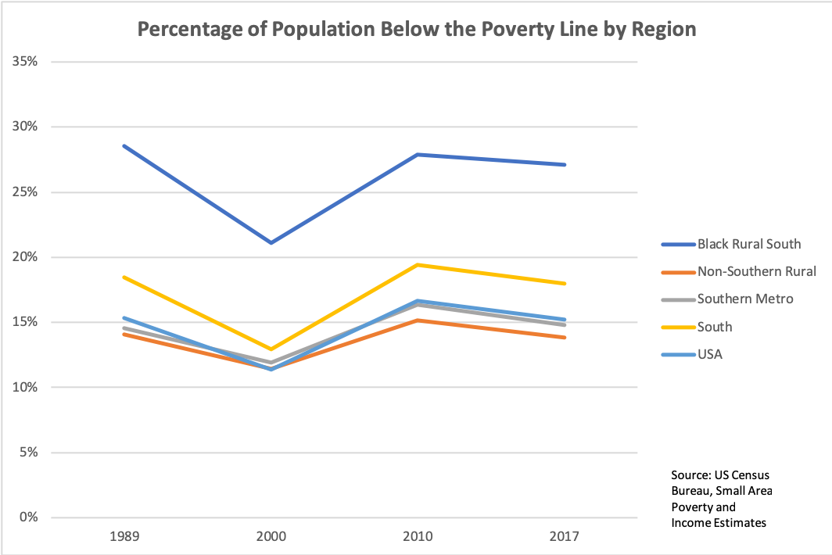**placeholder**

**[TO DO: WHITE EARNINGS]**



Figure 10

**placeholder**

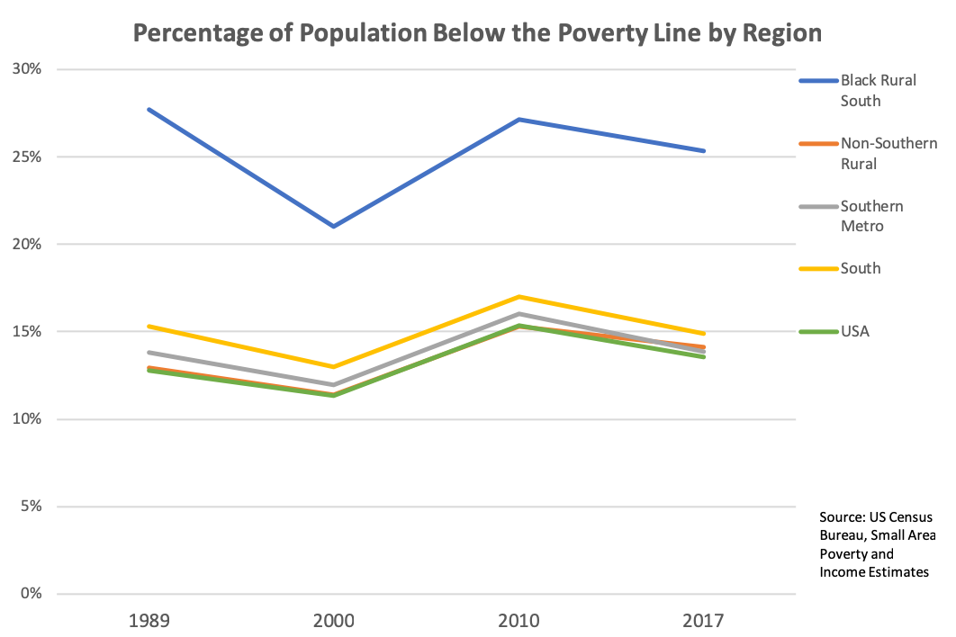**Poverty**

Figure 11: Percentage of Population Below the Poverty Line in 1989, 2000, 2010, and 2017, weighted by 1990, 2000, 2010 Census Bureau Population and 2013-2017 ACS Population estimates respectively, of counties in the Black Rural South, Rural counties not in the South, Metro counties in the South, Southern counties, and the entire USA. This figure is **not** broken down by race.

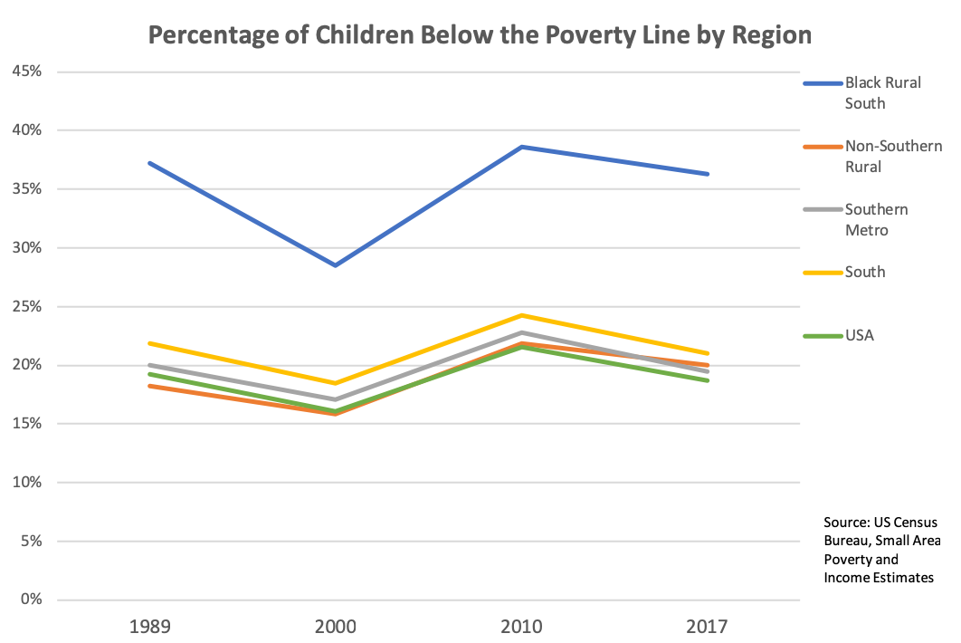

Figure 12: Percentage of Population Under 18 Below the Poverty Line in 1989, 2000, 2010, and 2017, weighted by 1990, 2000, 2010 Census Bureau Population and 2013-2017 ACS Population estimates respectively, of counties in the Black Rural South, Rural counties not in the South, Metro counties in the South, Southern counties, and the entire USA. This figure is **not** broken down by race, and has **not** been adjusted for inflation.

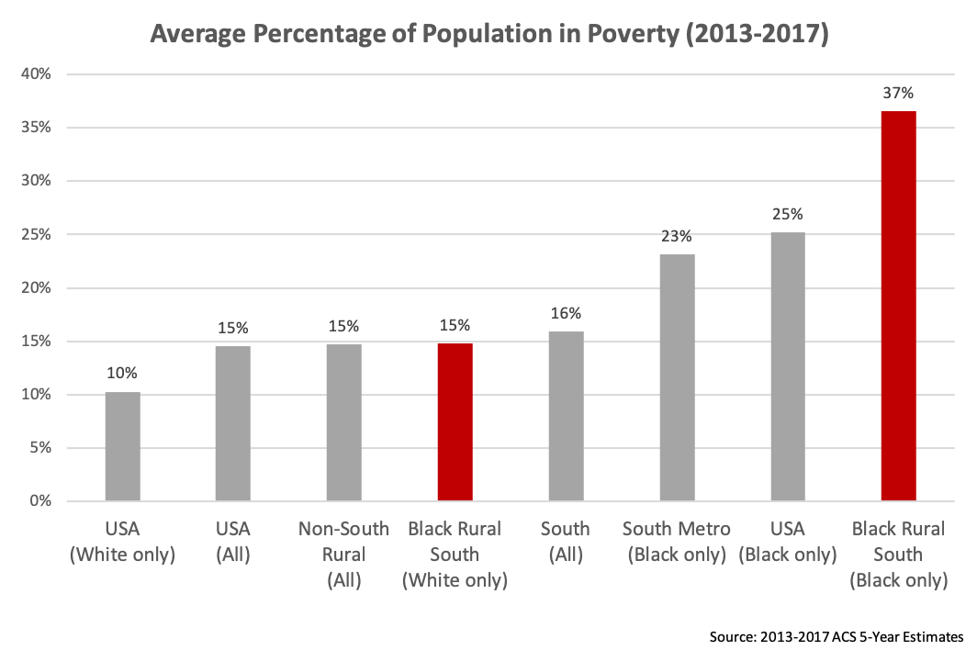

Figure 13: Percentage of Population for which Poverty Status is Determined that is Below the Poverty Line, averaged over 2013-2017. Data is for counties in the Black Rural South, Rural counties not in the South, Metro counties in the South, Southern counties, and the entire USA, for the whole population and for demographic categories ‘Black or African American Alone’ and ‘White Alone, Not Hispanic or Latino’. Note that the Poverty Rate among Whites in the Southern Metro counties, omitted from this graph, is 10%.

* 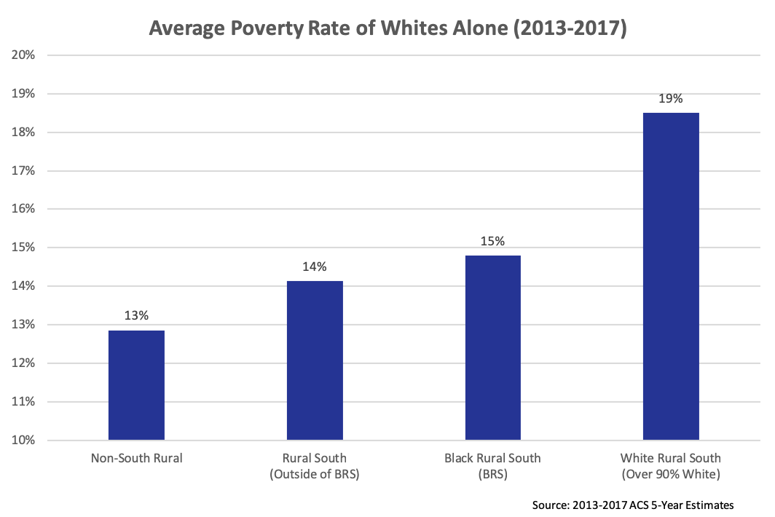

Figure 14: Percentage of Population for which Poverty Status is Determined that is Below the Poverty Line, averaged over 2013-2017, for ‘White Alone, Not Hispanic or Latino’. Data is for counties in the Black Rural South, Rural counties not in the South, Rural counties in the South that are not part of the ‘Black Rural South’, and White Rural South (Rural Counties in the South that are over 90% White).

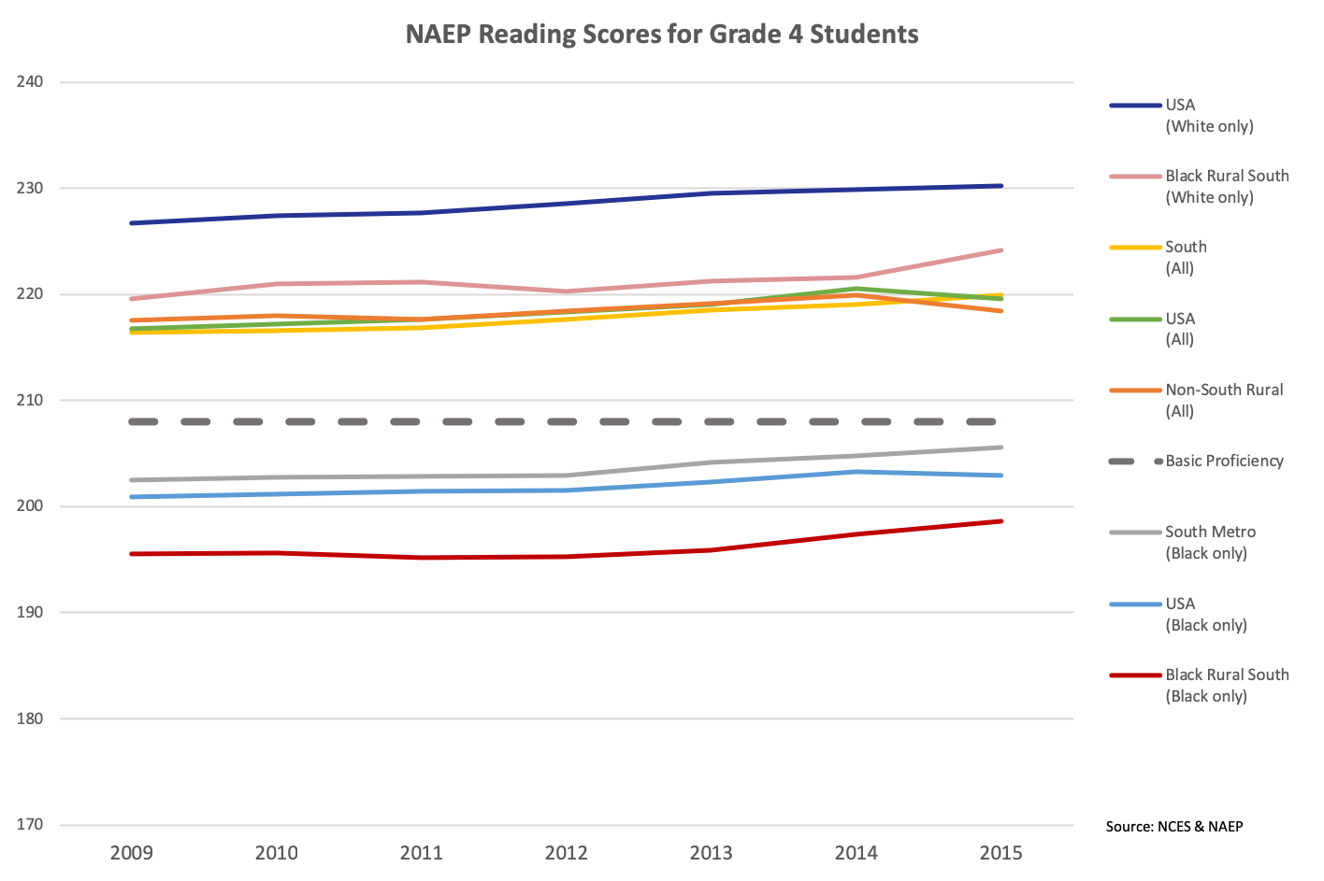**Education**

Figure 15: Average Reading score among students in Grade 4 on the National Assessment of Educational Progress (NAEP), from 2009 to 2015. Data is for counties in the Black Rural South, Rural counties not in the South, Metro counties in the South, Southern counties, and the entire USA, for the whole population and for demographic categories ‘Black or African American Alone’ and ‘White Alone, Not Hispanic or Latino’. Note that the NAEP Reading Score among Whites in the Southern Metro counties, omitted from this graph, closely tracks the Whites in the USA, but is roughly one point higher.

* a

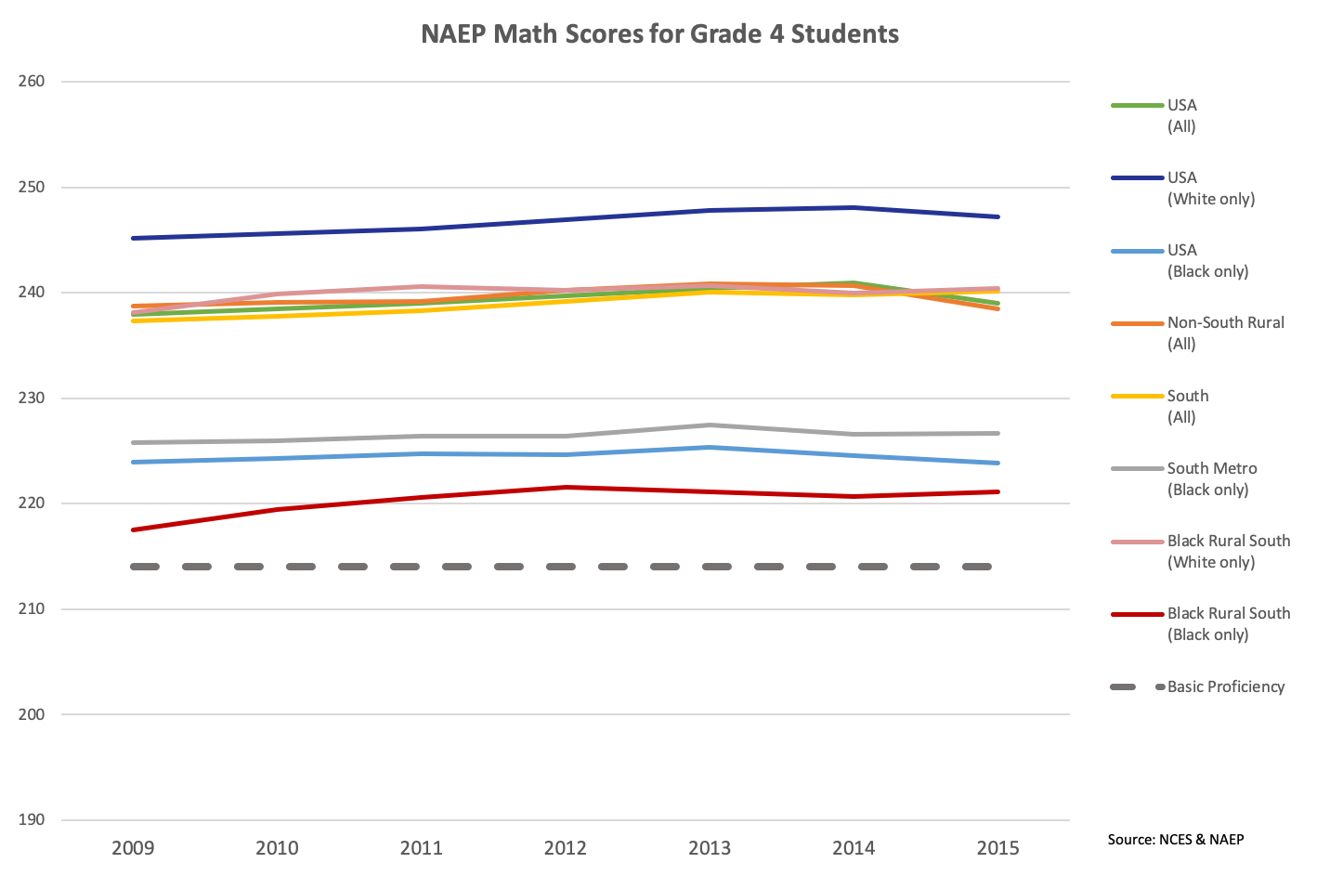

Figure 16: Average Math score among students in Grade 4 on the National Assessment of Educational Progress (NAEP), from 2009 to 2015. Data is for counties in the Black Rural South, Rural counties not in the South, Metro counties in the South, Southern counties, and the entire USA, for the whole population and for demographic categories ‘Black or African American Alone’ and ‘White Alone, Not Hispanic or Latino’. Note that the NAEP Reading Score among Whites in the Southern Metro counties, omitted from this graph, closely tracks the Whites in the USA, but is roughly 0.5 points higher.

* a

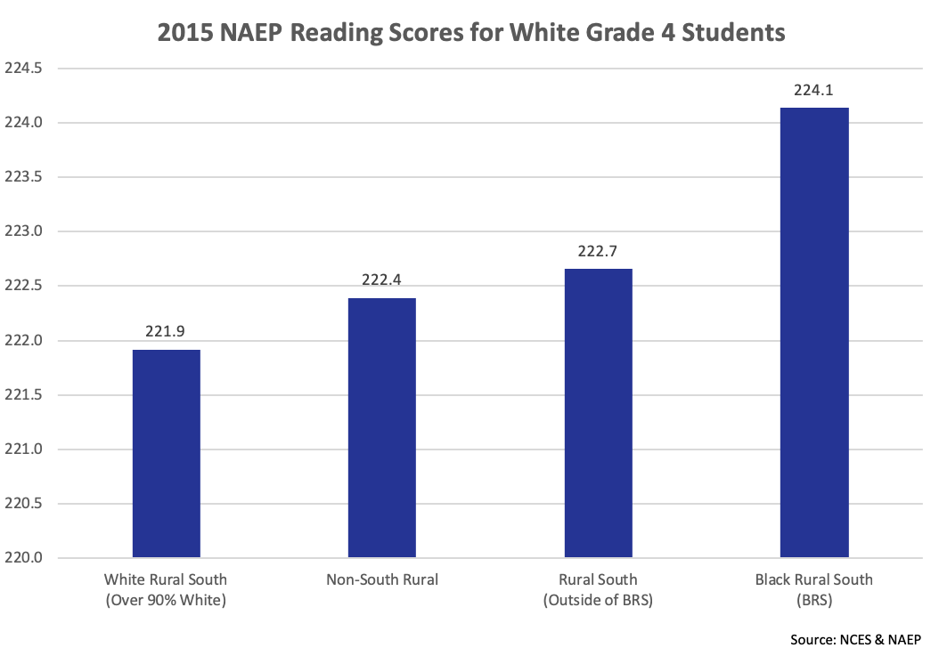

Figure 17: Average Reading score among White students in Grade 4 on the National Assessment of Educational Progress (NAEP), from 2009 to 2015. Data is for counties in the Black Rural South, Rural counties not in the South, Rural counties in the South that are not part of the ‘Black Rural South’, and White Rural South (Rural Counties in the South that are over 90% White).

* 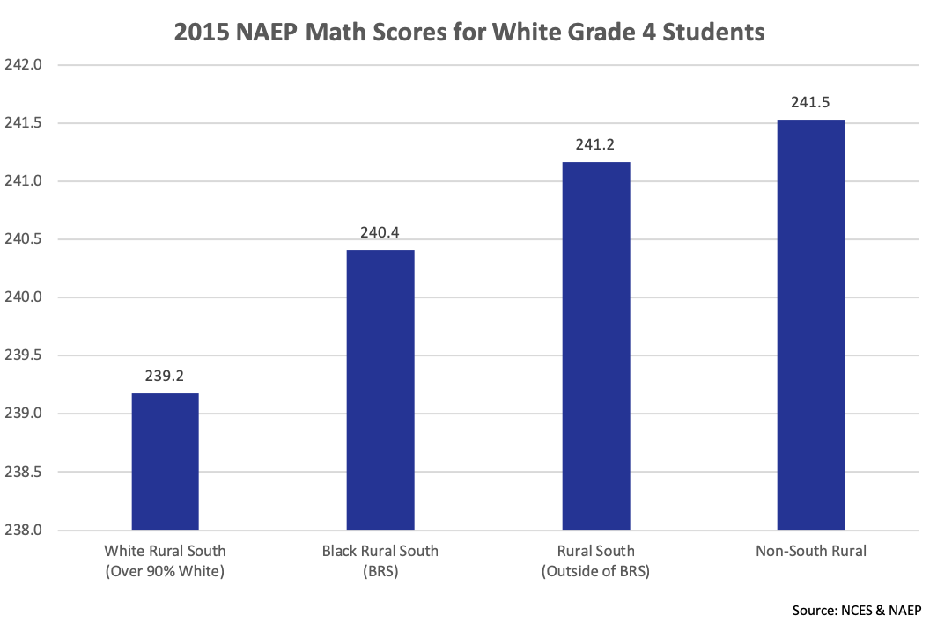

Figure 18: Average Math score among White students in Grade 4 on the National Assessment of Educational Progress (NAEP), from 2009 to 2015. Data is for counties in the Black Rural South, Rural counties not in the South, Rural counties in the South that are not part of the ‘Black Rural South’, and White Rural South (Rural Counties in the South that are over 90% White).

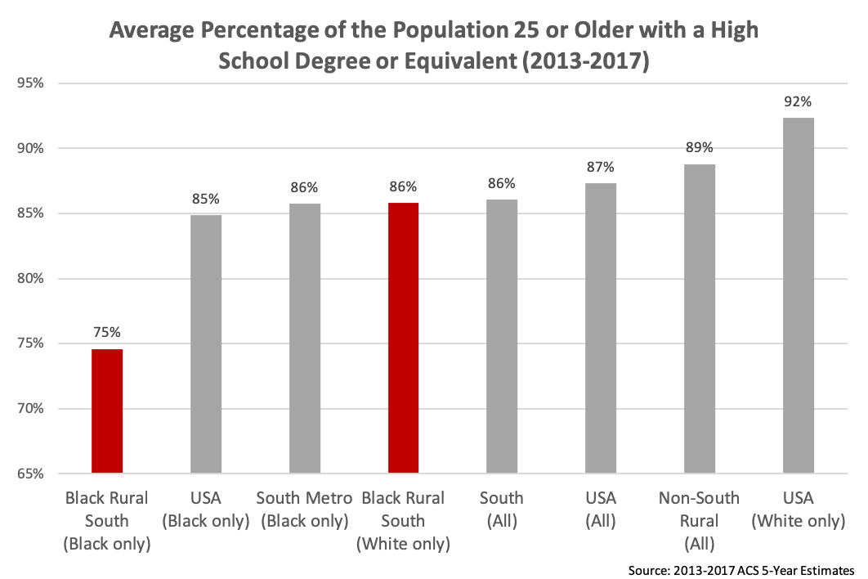

Figure 19: Percentage of Population over the age of 25 with a High School Diploma or Equivalent (such as a GED), averaged over 2013-2017. Data is for counties in the Black Rural South, Rural counties not in the South, Metro counties in the South, Southern counties, and the entire USA, for the whole population and for demographic categories ‘Black or African American Alone’ and ‘White Alone, Not Hispanic or Latino’. Note that the Percentage of Whites in the Southern Metro counties with a high school degree or equivalent, omitted from this graph, is 92%.

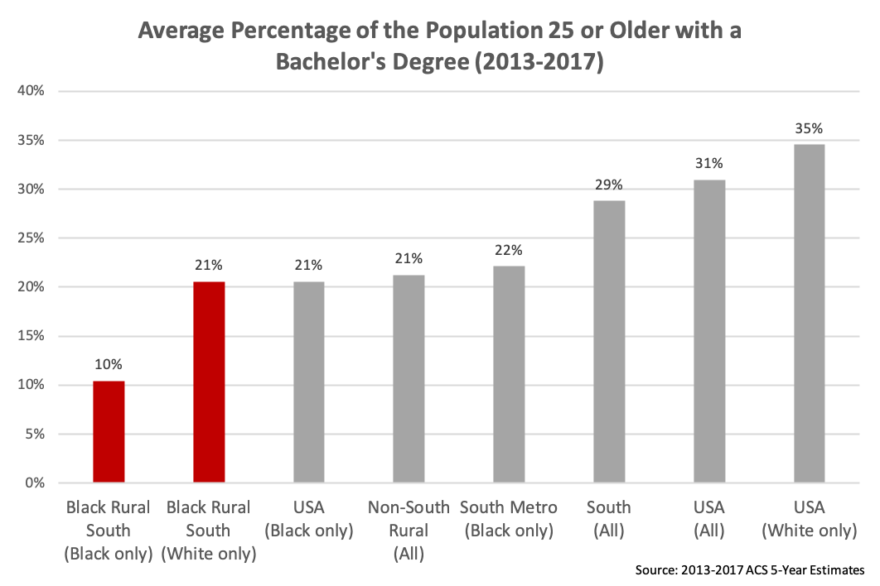

Figure 20: Percentage of Population over the age of 25 with a Bachelor’s Degree averaged over 2013-2017. Data is for counties in the Black Rural South, Rural counties not in the South, Metro counties in the South, Southern counties, and the entire USA, for the whole population and for demographic categories ‘Black or African American Alone’ and ‘White Alone, Not Hispanic or Latino’. Note that the Percentage of Whites in the Southern Metro counties with a bachelor’s degree, omitted from this graph, is 36%.

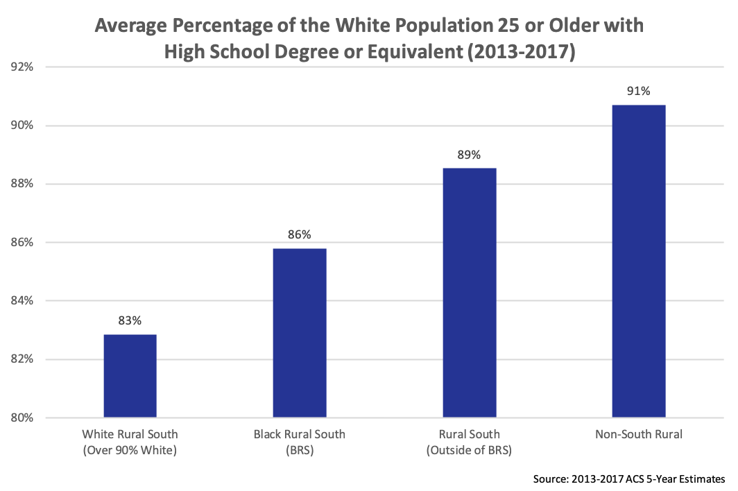

Figure 21 Percentage of Population over the age of 25 with a High School Diploma or Equivalent (such as a GED), averaged over 2013-2017, for ‘White Alone, Not Hispanic or Latino’. Data is for counties in the Black Rural South, Rural counties not in the South, Rural counties in the South that are not part of the ‘Black Rural South’, and White Rural South (Rural Counties in the South that are over 90% White).

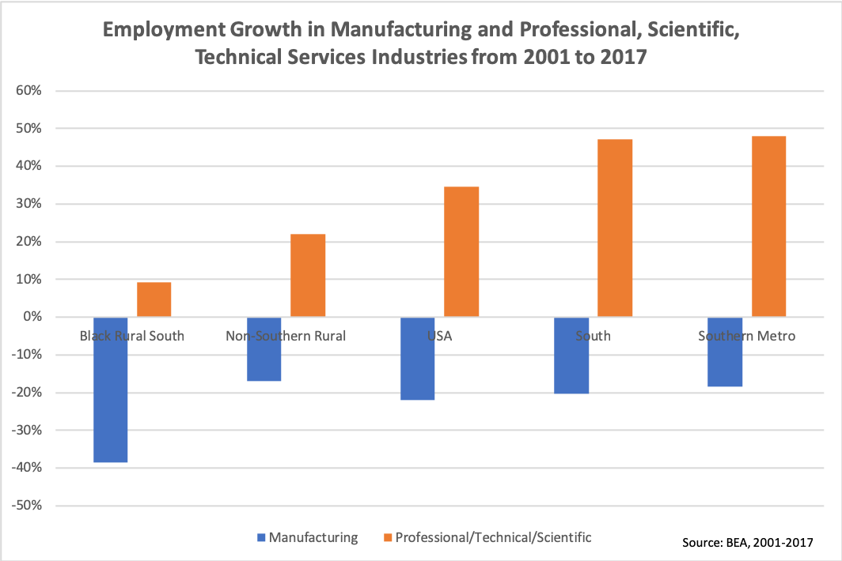**Industries & Productivity**

* **TO BE UPDATED FOR NEW COUNTIES**

**The Present Status of Work in the Black Rural South**

**Commission**

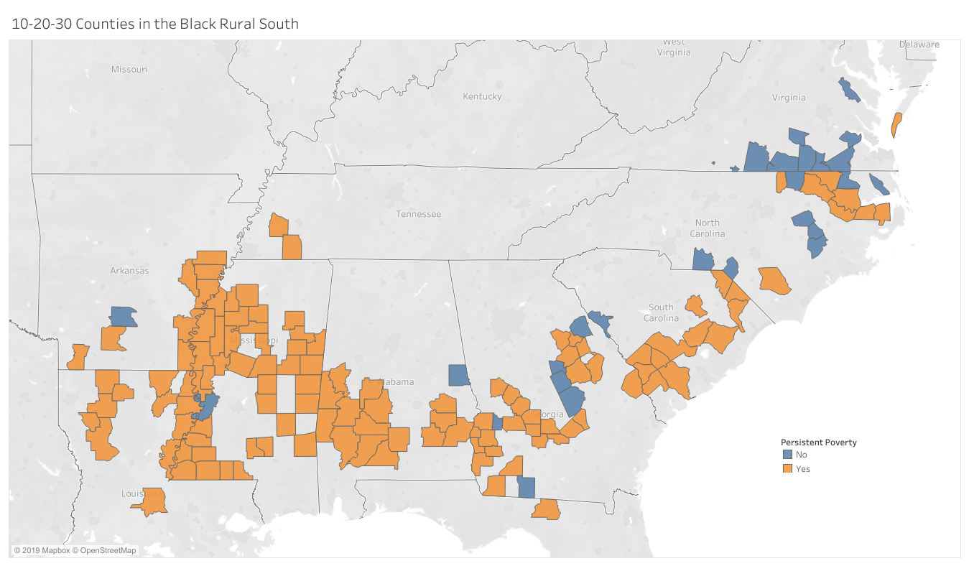**10/20/30**

* **To be updated for new counties, adding metro cities to map**

**HBCU as Infrastructure**

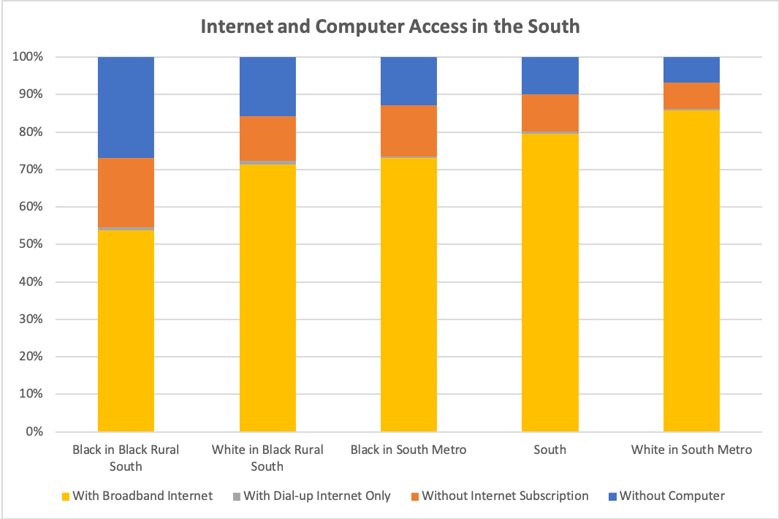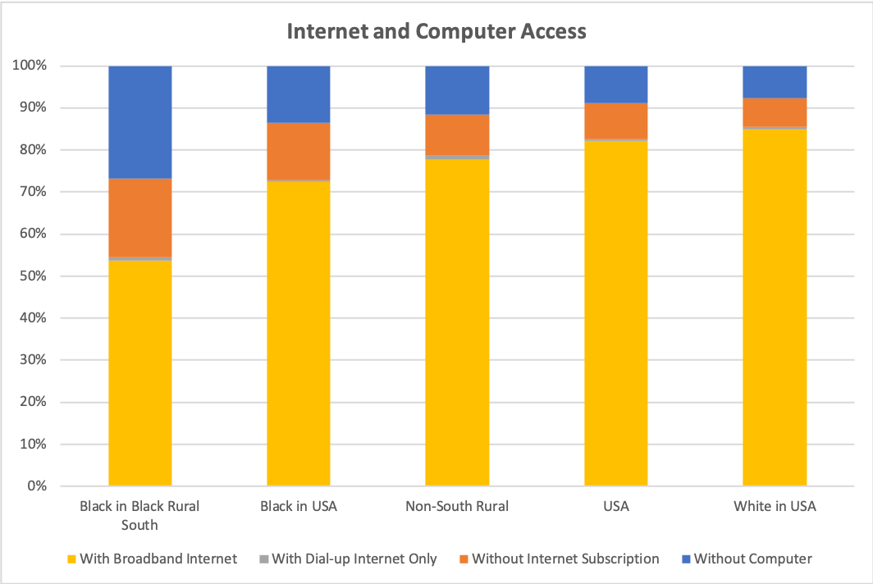**Broadband Connectivity**

* **To be updated for new counties and combined into one graph**

**Education**

**Skills & Entrepreneurship**

**Work Supports (Transportation, Child Care)**